Industrial IoT Automotive System Analysis: Bajaj Chetak 3501
Date: May 8, 2026
Subject: Connected Electric Vehicle (CEV) System Analysis
1. Executive Summary
The Bajaj Chetak 3501 is a connected electric scooter that exemplifies modern IIoT (Industrial Internet of Things) in the automotive sector. It integrates advanced hardware (3.5 kWh battery, motor, TFT display) with edge computing (Telematics Control Unit - TCU) and cloud-based services via MY CHETAK APP connectivity. This system enables real-time monitoring, remote diagnostics, theft detection, and over-the-air (OTA) updates, transforming a vehicle into a data-driven, manageable asset. [1, 2, 3, 4, 5]
2. Architectural Analysis
The Chetak 3501 architecture is a five-layer IIoT framework:
- Device Layer (Physical): Components including the 3.5 kWh battery, 4 kW motor, sensors (speed, throttle, brake), and the 5-inch TFT touchscreen.
- Connectivity Layer: The system uses 4G LTE/GSM for cloud communication and BLE (Bluetooth Low Energy) for My Chetak App to phone connection.
- Edge Layer (TCU): An embedded Telematics Control Unit (TCU) that processes data locally, handles safety-critical tasks, and buffers data during network outages.
- Cloud Layer (Bajaj IoT Platform): Centralized servers that store telemetry data, manage vehicle twins, handle user authentication, and send OTA updates.
- Application Layer (User Interface): The My Chetak App (Android/iOS) and the scooter’s TFT screen providing navigation, diagnostics, and vehicle management. [6, 7, 8, 9, 10]
Architectural Diagram
(Imagine a diagram with Vehicle Sensors -> TCU (Edge) -> 4G/LTE -> Cloud -> User App)
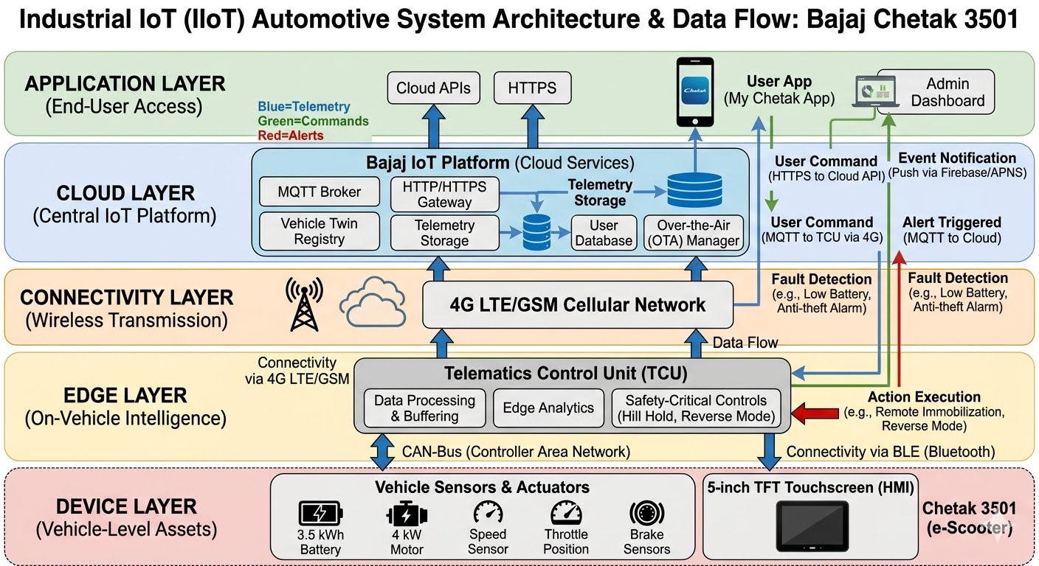
3. Edge vs. Cloud Intelligence
Feature | Edge Intelligence (TCU) | Cloud Intelligence (Server)
Responsibility | Real-time, safety-critical actions | Long-term data analysis, AI training
Response Time | <10 ms (Instant) | ~100–500 ms (Depends on network)
Example | Hill hold assist, Anti theft alarm | Ride analytics, predictive maintenance
Justification for Safety-Critical Edge Processing:
Safety functions like anti-theft immobilization (remote immobilization) or hill-hold must operate instantly regardless of network connectivity. Relying on the cloud for these tasks could lead to accidents if the 4G network fails, whereas local edge computing ensures reliability. [2, 3, 11]
4. Data Flow
- Telemetry Upload (Vehicle to Cloud): The TCU continuously collects battery status (SOC), GPS position, motor speed, and riding behavior via CAN bus, sending this encrypted data to the cloud periodically.
- User Commands (App to Vehicle): When a user triggers remote immobilisation or reverse mode via the app, the command travels through the internet to the cloud, which pushes it to the vehicle's TCU.
- Event Notifications (Vehicle to App): If the anti-theft alarm is triggered (e.g., unauthorized movement), the TCU immediately sends an alert through the 4G network to the user's phone. [9, 12, 13, 14]
5. Protocol Stack
- Application Layer: MQTT for lightweight, persistent messaging; HTTPS for secure user authentication.
- Network/Transport Layer: TCP (reliable telemetry) / UDP (potential for rapid alerts).
- Physical Layer: IP (over 4G LTE) and BLE. [8]
6. Event-Driven Behavior
The Chetak 3501 is designed to react to specific, triggered events:
- Low Battery Alert: Triggered by TCU when SOC drops below 15%.
- Theft Detection/Geo-fencing: An alert is generated if the scooter moves outside a pre-set digital boundary when locked.
- Fault Detection: Real-time monitoring for motor or battery faults. [12, 13, 14, 15, 16]
7. Performance & Scalability
- Latency: Critical for remote commands (<500ms).
- Bandwidth: Low for status updates, high when pushing firmware updates (OTA).
- Scalability: Challenges include managing millions of simultaneous connections during peak times. The platform must use load balancers to prevent My Chetak App slowdowns. [3, 8, 17]
8. Security Analysis
- Authentication: User login to app (OAuth), Vehicle-to-Cloud mutual authentication.
- Encryption: Data transmitted via MQTT/HTTPS is encrypted to prevent man-in-the-middle attacks.
- Vulnerabilities: Potential for Bluetooth spoofing and data privacy issues regarding user location history. [6, 8, 12, 18]
9. Critical Evaluation: Distributed Alternative
Instead of a purely centralized cloud, a distributed edge architecture could be used.
- Proposed Alternative: Deploy MQTT brokers at the edge (regional edge nodes) rather than only in the central cloud.
- Trade-offs: This reduces latency for remote commands (faster response) and improves data sovereignty, but increases infrastructure management complexity. [3, 19]
10. Failure Scenarios
- Network Failure (4G Down): The scooter operates normally, but app-based remote tracking and remote immobilization stop working. Local Bluetooth can still control some functions.
- Cloud Failure: Live telemetry data is lost, but the TCU can buffer critical events to send later.
- Device Failure (TCU): The scooter may not start or run safely, necessitating a physical key override if available. [3, 8, 14]
11. Conclusion
The Bajaj Chetak 3501 is a genuine Industrial IoT system because it utilizes interconnected, sensor-enabled hardware (TCU) to perform real-time, remote actions over a 4G network. [20]
- Strengths: Enhanced security (anti-theft), remote diagnostics, and smooth user experience.
- Limitations: High dependence on 4G network for advanced features and potential privacy concerns. [8, 12, 18, 21]
It effectively bridges physical mobility with digital convenience, highlighting the future of urban transportation.

[1] https://www.youtube.com
[2] https://www.chetak.com
[3] https://www.scribd.com
[4] https://appinventiv.com
[5] https://www.luxoft.com
[6] https://play.google.com
[7] https://www.youtube.com
[8] https://www.chetak.com
[9] https://www.rishabhsoft.com
[10] https://lampa.dev
[11] https://www.chetak.com
[12] https://www.chetak.com
[13] https://www.youtube.com
[14] https://www.youtube.com
[15] https://www.chetak.com
[16] https://rjpn.org
[17] https://www.emqx.com
[18] https://autos.maxabout.com
[19] https://inductiveuniversity.com
[20] https://www.seco.com
[21] https://ieeexplore.ieee.org

